WW1 LYDIATE Artefacts Collection Page 1
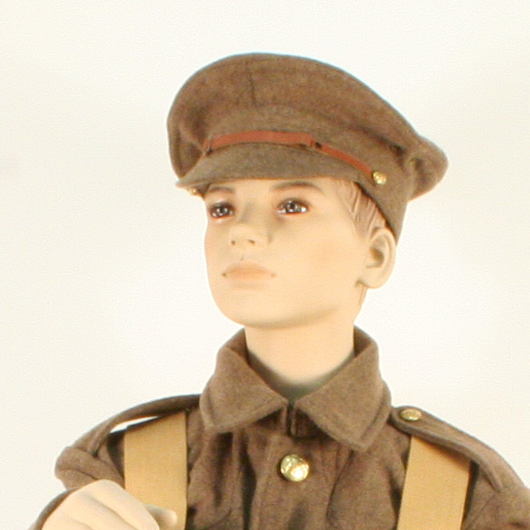 | Trench Cap  The WW1 British Army trench cap was issued from 1915 to Tommy soldiers serving in the trenches as it was more practical to wear and carry in their pocket when wearing the brodie helmet as the stiff SD cap proved impractical.
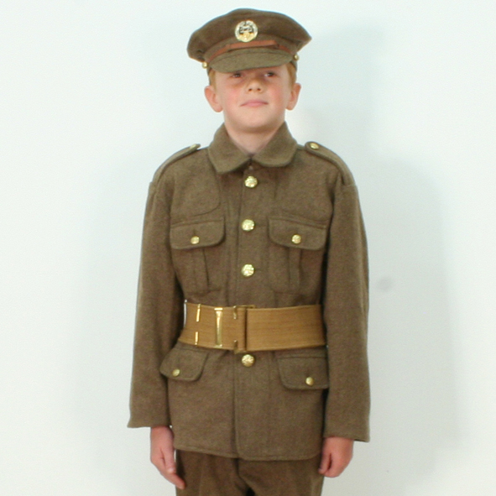 | Tunic  This is a replica tunic of the British Military 1902 Service Dress tunic which was used by the British Army in the Great War of 1914 to 1918.  The 1902 Pattern Service Dress tunic was the standard uniform clothing used by the British Army throughout the First World War.
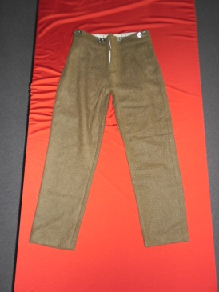 | Trousers  Khaki trousers were worn by soldiers on the Western Front as part of standard army uniform.
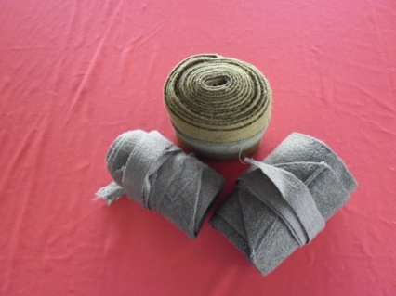 | Puttees (x2)  Cloth that was wrapped around the ankles and calves providing protection and support against the trench conditions. The puttees were about 6 feet long and 4inches wide and tied with tapes: They were wound in a spiral up the calf to ensure a secure and neat seal between the boots and the trouser-legs. They were inexpensive, but by WW2 had been phased out due to the time required to put them on and concerns about hygiene. They were no use against trench foot and if worn tightly may even have contributed.
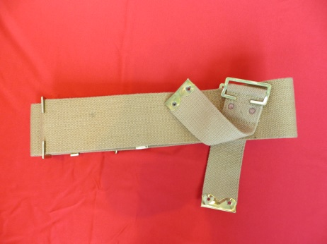 | Webbing Belt  Worn around the waist and attached to shoulder straps as a means of attaching and carrying pouches, etc.
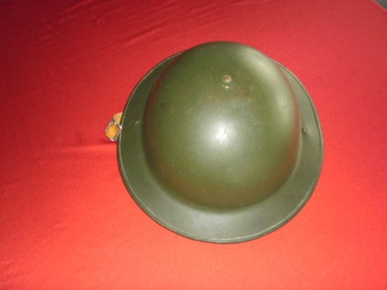 | Brodie helmet.  Steel helmets were introduced in 1915 when it became apparent that too many soldiers were dying from head wounds caused by flying shrapnel. They only became mandatory standard issue in the summer of 1916 Rimmed helmets were introduced in 1917. They were painted or worn with a cover to reduce shine. The chinstraps were designed to break in the event of a blast to prevent neck injury.

