WW1 LYDIATE ARTEFACTS BOX PAGE 2

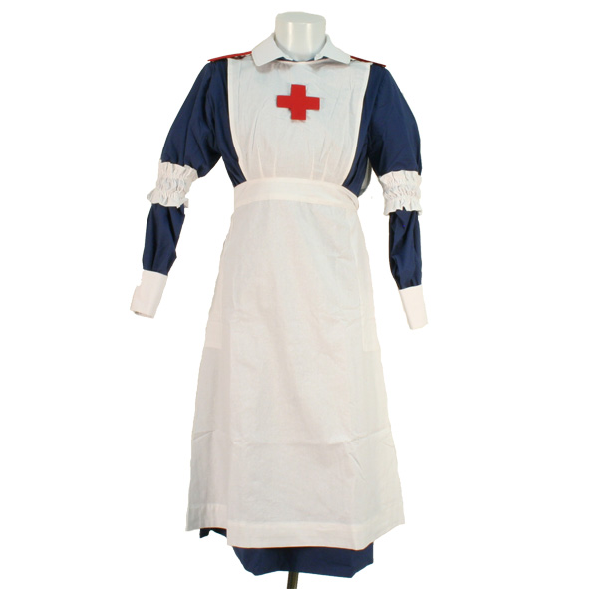 | WW1 Children's VAD (Voluntary Aid detachment) blue cotton ward dress.  - Full length Blue cotton dress  - removable cotton collar  - Removable Shoulder board  - white apron  - White cuffs  - white elasticated arm bands  - Head scarf
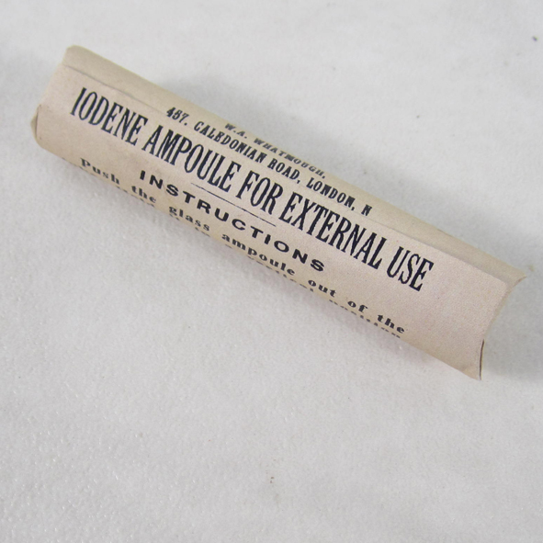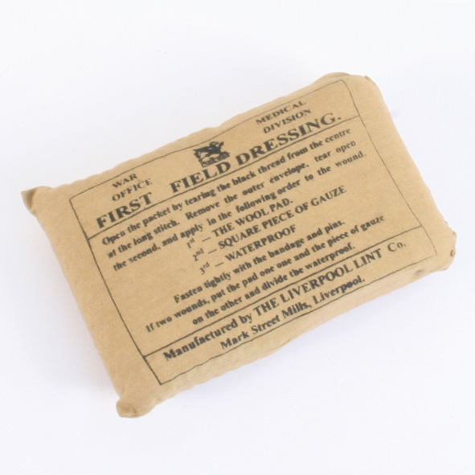 | Iodene Ampule and Field Dressing  During the great war 1914-1918 the British army soldier was issued very basic first aid kit which usually consisted of just one first field dressing which he kept in his tunic pocket.  If he was lucky he might have been able to acquire an Iodine ampoule which he would break on a hard surface and then pour the contents over his first Field dressing to help clean the wound and prevent infection.  These replica has packaging copied from an original with instructions on how to use. Please do not open.
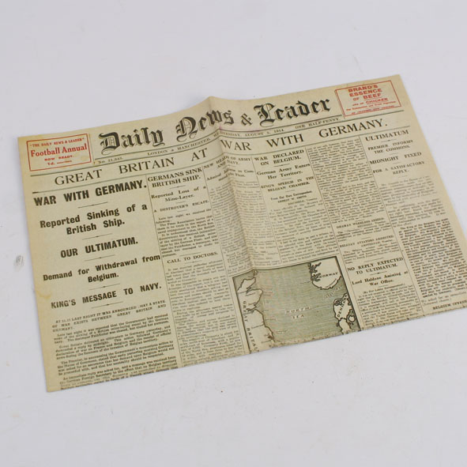 | Outbreak of WW1 Newspaper  A reprint of the Daily News from 5th August 1914 when Britain had declared war on Germany the previous evening.  A complete 8 page broadsheet paper covering all the news of the day and more.
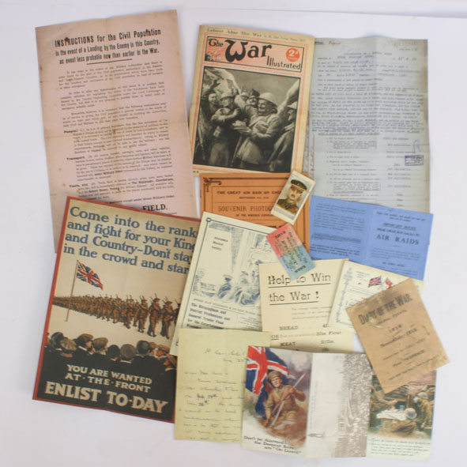 | WW1 Paperwork Pack  The set consists of reprints of original first war paperwork.  Contents includes:  - Home Front information inc what to do in event of an invasion.  - Medical report 1917  - Enlist to-day poster  - The war illustrated  - Collectors cards  - Air raids Notice  - Booklet on the Zepplin  - and more

